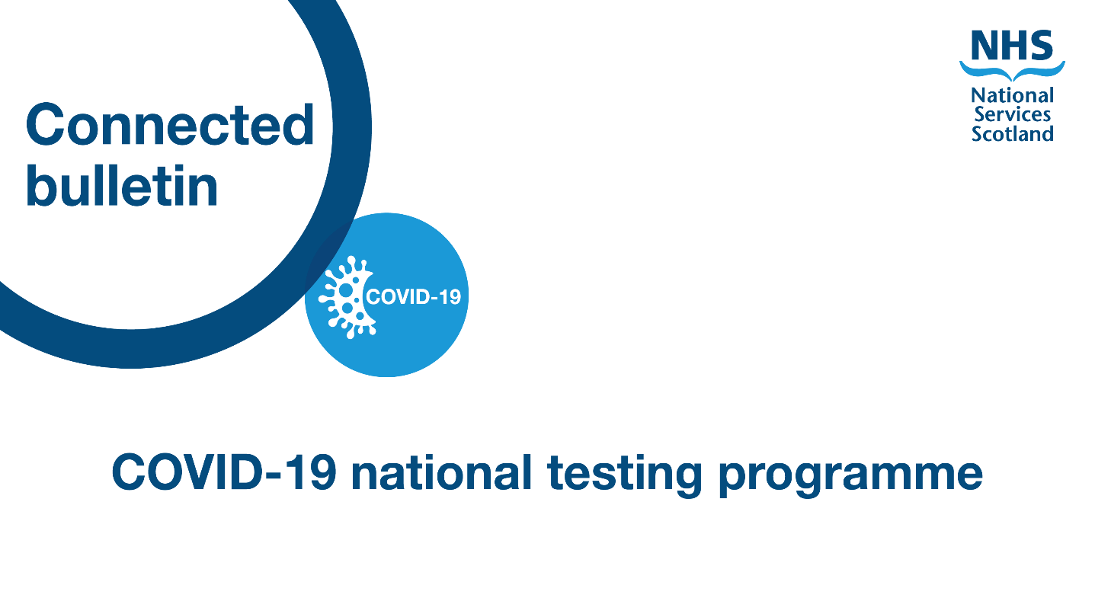

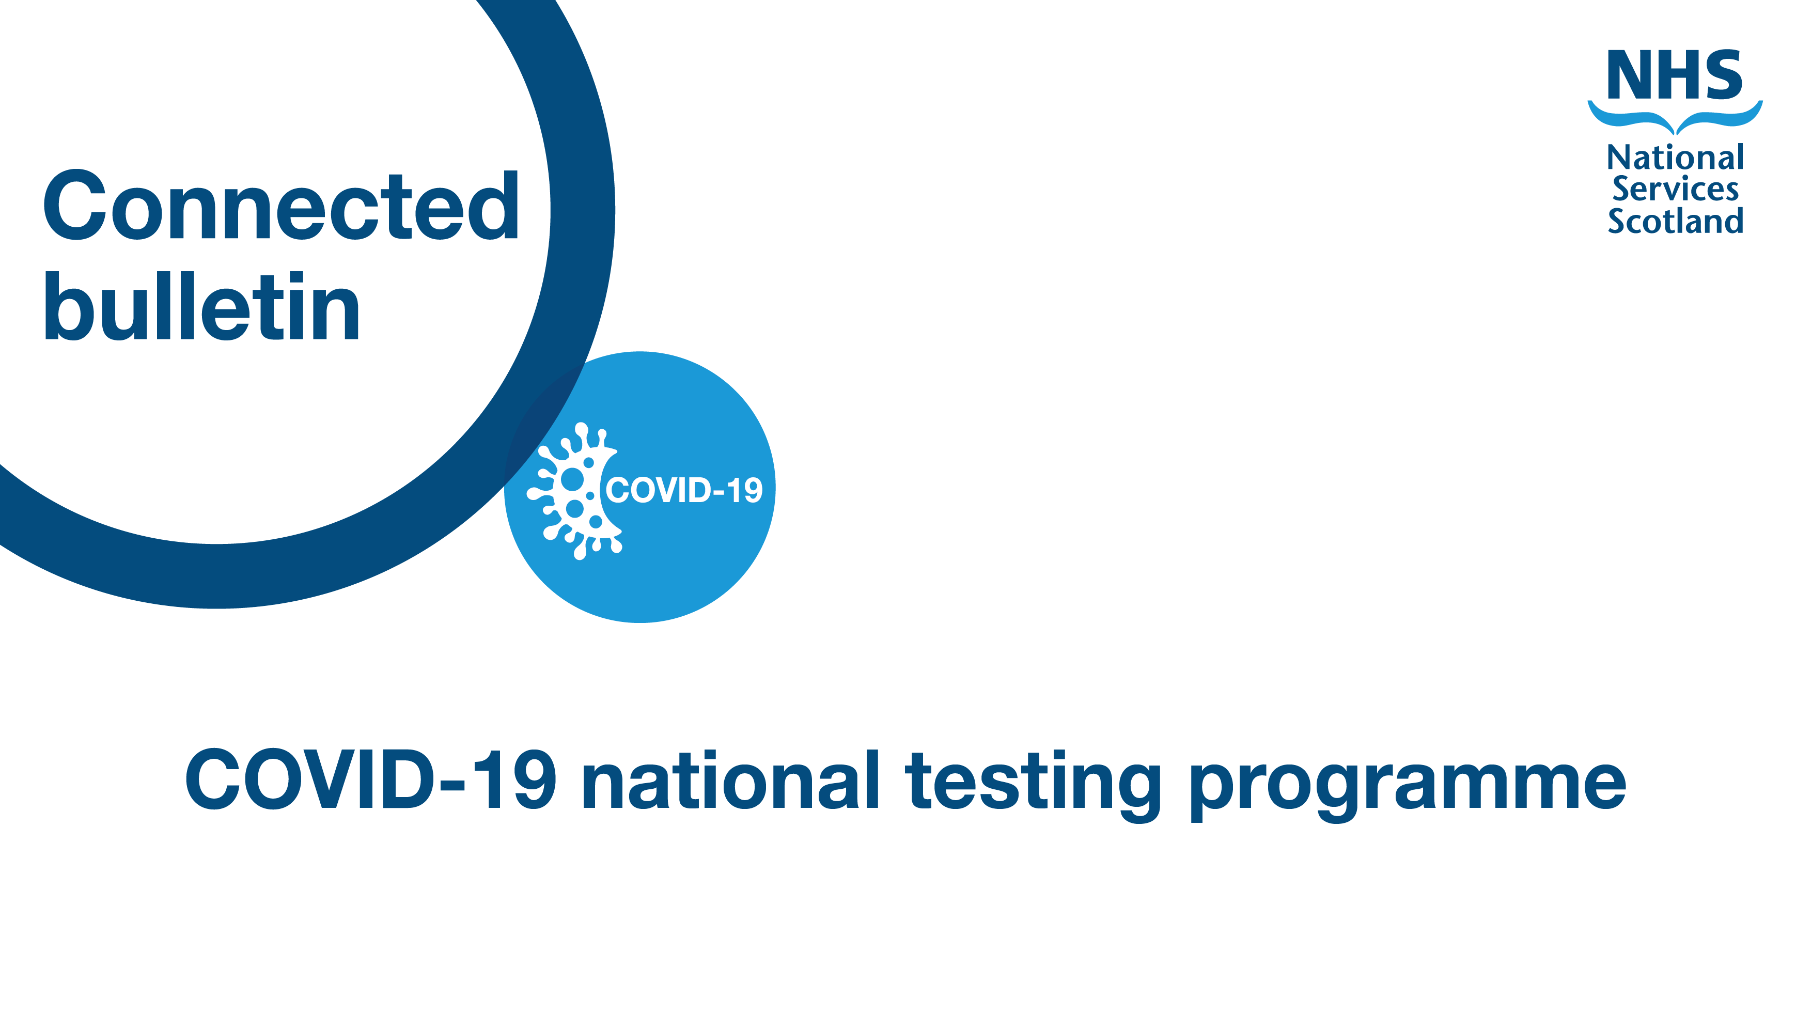

**Wastewater testing for COVID-19 in Scotland**

**Scotland’s pioneering project to monitor COVID-19 outbreaks by measuring its genetic footprint in wastewater began in May 2020.**  Wastewater samples are collected regularly across the country and analysed for the SARS-CoV-2 virus. Wastewater monitoring is one of the systems used to detect new COVID-19 outbreaks within the population and support test and trace approaches.

Wastewater testing in Scotland is a collaborative approach between the Scottish Environment Protection Agency (SEPA), the Scottish Government, Scottish Water and Scottish universities. Scottish Water collects samples from waste water treatment works across the country, and SEPA analyses them in its laboratory near Eurocentral. We caught up with Peter Singleton from SEPA to discuss how wastewater testing works in Scotland.

**How wastewater testing became another method of testing for COVID-19**

Although innovative, wastewater testing is not a new process - it’s also used to test for other infections such as norovirus and Polio. However, this existing process has been adapted to allow for COVID-19 testing in our communities.

The technology which has enabled wastewater testing in Scotland already existed pre-COVID-19. However, the organisations and individuals working to make wastewater testing a viable method for COVID-19 testing had to come up with the correct methodology to make sure the tests worked and the data presented was accurate.

In order to be able to get as much data as possible, Peter explains SEPA first went to the larger sewage works, as this would “allow them to not only test as much of the population as possible, but also enable them to gather data for many health board areas too.” Peter added that even at this early stage they were able to “assess the level of COVID-19 present in up to 50% of the Scottish population.”

Current monitoring is focussed on supporting the community testing programme and the 200 samples analysed a week come from treatment works covering over 70% of the Scottish population.

**The advantages of wastewater testing as a method**

Wastewater testing offers an “unbiased and independent account of the level of COVID-19 within a community,” according to Peter. However, this is “an overview, and will not provide data on individual cases.”

Peter added that wastewater testing is “useful for monitoring a rise in COVID-19 within communities” and cited the spike of winter 2020 as an example where SEPA could “see the levels of COVID-19 increasing as the winter drew in.”

**The challenges of using wastewater testing to detect COVID-19**

SEPA is keen to emphasise that wastewater testing “can be used as an early warning for COVID-19 levels,” but this isn’t always an accurate reflection. They emphasised caution when using the data for this purpose.

Instead, wastewater testing, used alongside other data,helps individual health boards and the Scottish Government to determine what areas or communities may benefit from additional in-person testing. An example is low testing numbers in a community where wastewater testing shows a spike in levels in the area. This scenario could suggest that local people aren’t proactively being tested for COVID-19 and would therefore benefit from extra testing resources.

Another challenge associated with wastewater testing is that most Scottish wastewater systems have a high infiltration of run-off water from rainfall. This makes testing wastewater for COVID-19 harder as the samples will be diluted so results from the labs must be adjusted accordingly.

Wastewater monitoring is most effective when integrated with other public health initiatives, such as clinical testing and contact tracing.

**What successes have been delivered to date?**

The team working on wastewater testing has successfully supported the NHS and the Scottish Government in monitoring overall levels and transmission of COVID-19 in Scotland’s communities.

**An additional £2.3 million of funding was announced by the Scottish Government in March this year, meaning the programme will run until March 2022. This means Scotland will continue to have a** richer picture of the prevalence of the virus – “which will be key in helping to inform the route out of lockdown.”

The next stage is to move to sequencing, which Peter advised is “how we can test for which variants of COVID-19 are circulating within a particular community.” This is a significant step given how much worry remains about different strains of COVID-19 and their impact on the health of individuals.

Several countries, including the UK, have now implemented national wastewater monitoring programmes for COVID-19.

|  |
| --- |
| Questions or feedback on our Testing capacity bulletin? [**Get in touch**](mailto:nss.Communications@nhs.net) |